Figure A1. Comparison of study complication rates to the ACS NSQIP risk calculator average risk of any complication for the procedures of interest.
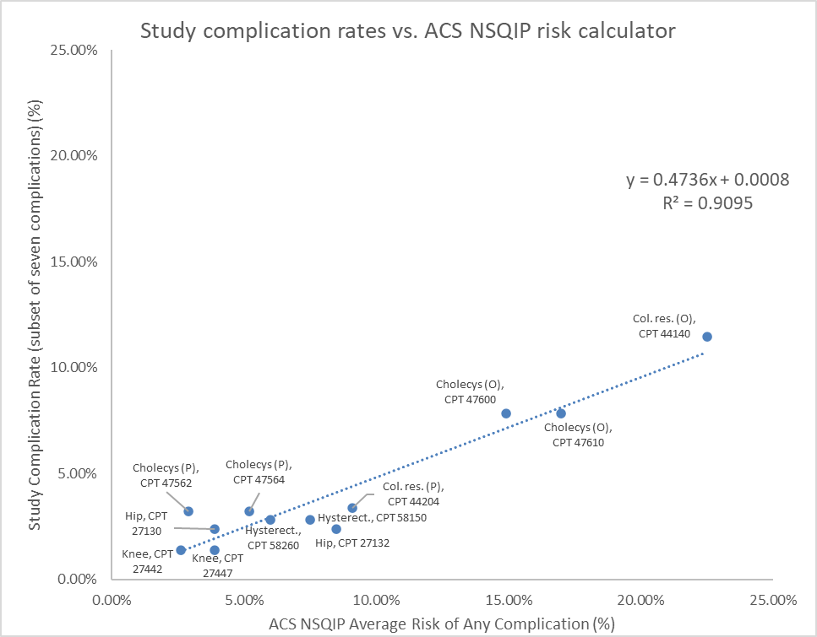
Figure A1. Comparison of the rate of the seven potentially preventable complications discussed in the paper to the ACS NSQIP average risk of developing any complication for those same procedures. For the labels used in the plot, the abbreviated study procedure names are separated by a comma from the CPT code used in the ACS NSQIP risk calculator. Abbreviations: Knee = Knee arthroplasty; Hip = Hip Replacement; Hysterect = Hysterectomy; Cholecys (P) = Cholecystectomy, Percutaneous Approach; Cholecys (O) = Cholecystectomy, Open Approach; Col. res. (P) = Colorectal Resection, Percutaneous Approach; Col. res. (O) = Colorectal Resection, Open Approach.

